ION7300.SNF (Modified)
//Format:
//Axxxxx=Name
//A represents an analog measurement.
//xxxxx is the Code number in PecConfig. It is defined by the driver. For ION meters, xxxxx is the correspond ION Handle in decimal, except from 1 to 31.
//Name is the name of the measurement.

//Black: Not changed
//Red: The Code number is changed
//I4, V4, I5 Harmonics are not supported by ION7300. So the registers are deleted.
//Blue: Not changed. Need to check the ION module # of the registers from the ION7300 meter.
A0=Vlnavg
A1=Va
A2=Vb
A3=Vc
A4=Vllavg
A5=Vab
A6=Vbc
A7=Vca
A8=Iavg
A9=Ia
A10=Ib
A11=Ic
A12=I4
A13=V Unbalance
A14=I Unbalance
A15=kW Total
A16=kWa
A17=kWb
A18=kWc
A19=kVAR Total
A20=kVARa
A21=kVARb
A22=kVARc
A23=kVA Total
A24=kVAa
A25=kVAb
A26=kVAc
A27=PF Total
A28=PFa
A29=PFb
A30=PFc
A31=Frequency
A22704=kWh Import
A22705=kWh Export
A22706=kWh Total
A22707=kWh Net
A22708=kVARh Import
A22709=kVARh Export
A22710=kVARh Total
A22711=kVARh Net
A22712=kVAh Total
A22784=Va HD01
A22785=Va HD02
A22786=Va HD03
A22787=Va HD04
A22788=Va HD05
A22789=Va HD06
A22790=Va HD07
A22791=Va HD08
A22792=Va HD09
A22793=Va HD10
A22794=Va HD11
A22795=Va HD12
A22796=Va HD13
A22797=Va HD14
A22798=Va HD15
A22847=Va THD
A22848=Va TEHD
A22849=Va TOHD
A22850=Vb HD01
A22851=Vb HD02
A22852=Vb HD03
A22853=Vb HD04
A22854=Vb HD05
A22855=Vb HD06
A22856=Vb HD07
A22857=Vb HD08
A22858=Vb HD09
A22859=Vb HD10
A22860=Vb HD11
A22861=Vb HD12
A22862=Vb HD13
A22863=Vb HD14
A22864=Vb HD15
A22913=Vb THD
A22914=Vb TEHD
A22915=Vb TOHD
A22916=Vc HD01
A22917=Vc HD02
A22918=Vc HD03
A22919=Vc HD04
A22920=Vc HD05
A22921=Vc HD06
A22922=Vc HD07
A22923=Vc HD08
A22924=Vc HD09
A22925=Vc HD10
A22926=Vc HD11
A22927=Vc HD12
A22928=Vc HD13
A22929=Vc HD14
A22930=Vc HD15
A22979=Vc THD
A22980=Vc TEHD
A22981=Vc TOHD
A22982=Ia HD01
A22983=Ia HD02
A22984=Ia HD03
A22985=Ia HD04
A22986=Ia HD05
A22987=Ia HD06
A22988=Ia HD07
A22989=Ia HD08
A22990=Ia HD09
A22991=Ia HD10
A22992=Ia HD11
A22993=Ia HD12
A22994=Ia HD13
A22995=Ia HD14
A22996=Ia HD15
A23045=Ia THD
A23046=Ia TEHD
A23047=Ia TOHD
A23049=Ib HD01
A23050=Ib HD02
A23051=Ib HD03
A23052=Ib HD04
A23053=Ib HD05
A23054=Ib HD06
A23055=Ib HD07
A23056=Ib HD08
A23057=Ib HD09
A23058=Ib HD10
A23059=Ib HD11
A23060=Ib HD12
A23061=Ib HD13
A23062=Ib HD14
A23063=Ib HD15
A23112=Ib THD
A23113=Ib TEHD
A23114=Ib TOHD
A23116=Ic HD01
A23117=Ic HD02
A23118=Ic HD03
A23119=Ic HD04
A23120=Ic HD05
A23121=Ic HD06
A23122=Ic HD07
A23123=Ic HD08
A23124=Ic HD09
A23125=Ic HD10
A23126=Ic HD11
A23127=Ic HD12
A23128=Ic HD13
A23129=Ic HD14
A23130=Ic HD15
A23179=Ic THD
A23180=Ic TEHD
A23181=Ic TOHD
A22656=kW Total Demand
A22657=kVAR Total Demand
A22658=kVA Total Demand
A22659=Iavg Demand
A22778=kW Total Peak Demand
A22779=kVAR Total Peak Demand
A22780=kVA Total Peak Demand

How to change the ION7300 configurations using PecConfig
Change the ION7300 configurations one by one manually. Please do not use the Import SNF file method, otherwise, the data have to be relinked in PecDraw .
For example, the Property_Services_Main device(ION7300):
1) Click the mouse for twice in the Code cell of kVAh Total, change from 22714 to 22712.
Change the Code of Va THD and downwards to Ic TOHD according to the modified SNF file.
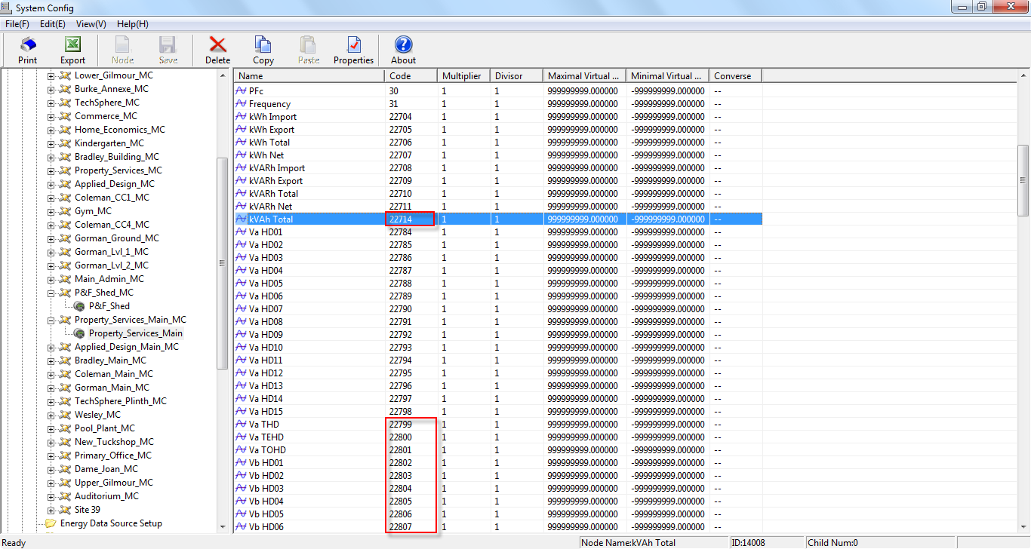
2) Press Shift and select from I4 HD01 to I5 TOHD and click Delete from the toolbar to delete them.
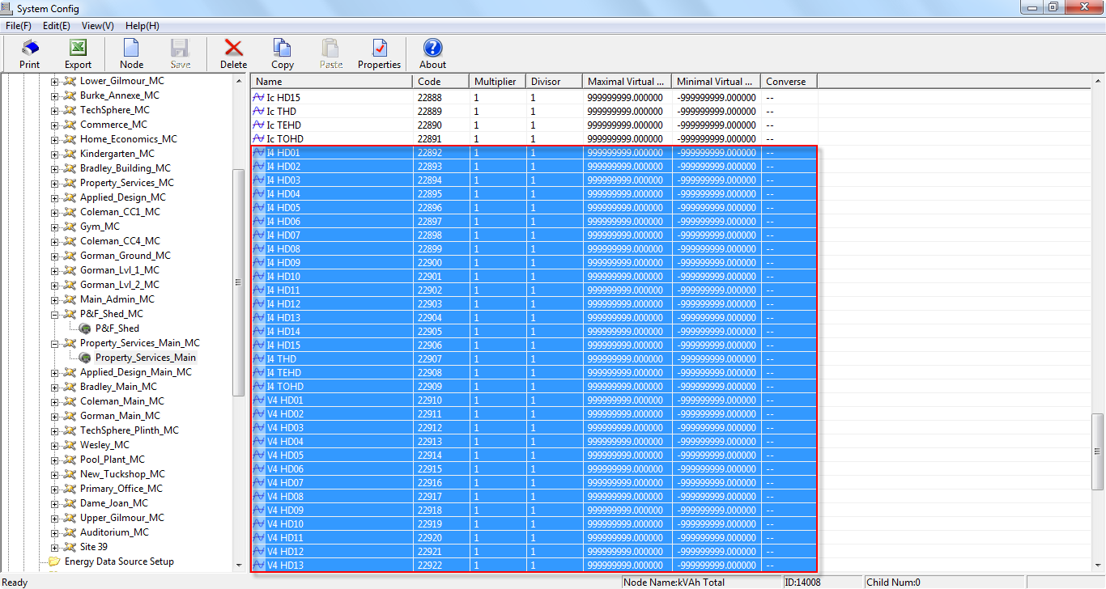
3) Check the ION Handle # of the SWinDemand modules and the Maximum modules of the sliding window demand and peak demand parameters.
4) Change the configurations of all other ION7300 meter in the same way.

